**Spectrophotometric Analysis: Phosphates in Water**

He Wenxin何雯欣

March 20, 2019

Student ID 518370910117

Section 3

Group 3

Members Qiu Jiahao 裘嘉豪

Feng Hanyang 冯瀚扬

Xu Jiaying 许佳滢

Telephone 15921193245

Email Address wenxin\_he@sjtu.edu.cn

University of Michigan-Shanghai Jiao Tong University Joint Institute(UM-SJTU JI)

# Ⅰ OBJECTIVES

* Doing calculations and diluting solutions
* Using spectrophotometric analysis to find out the concentration of phosphate in a given water sample
* Setting up and applying a calibration curve
* Cooperating with classmates

# Ⅱ INTRODUCTION

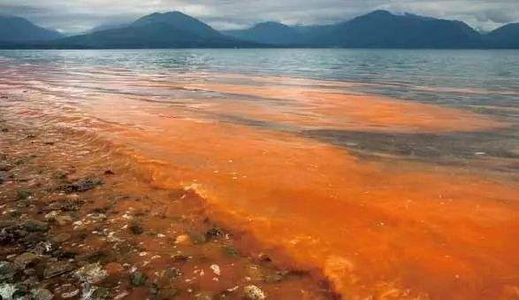

**Figure 1** the red tide problem

The eutrophication problem has affected the water systems all over the country, making them less appropriate for consumption and inhabiting. The problem results from extra nutrients poured into the water system, which nourishes algae and bacteria that compete for oxygen and hamper the original wildlife.

# Ⅲ BACKGROUND

The main water contaminants are phosphates. The primary use of them is to manufacture detergents and to serve as fertilizers. Their eventual home is the water system.

1. **Spectrophotometric Analysis and the Determination of Phosphate**

Light will be absorbed when passing through a solution. Different concentration of solution can absorb different amount of light. We can use this theory to determine the concentration of phosphate solution. We use an ammonium vanadomolybdate reagent to react with phosphates to color them. We can determine the concentration by analyzing the brightness of the resulting yellow solution.

A special instrument called a spectrometer is used to quantify the amount of light absorbed.

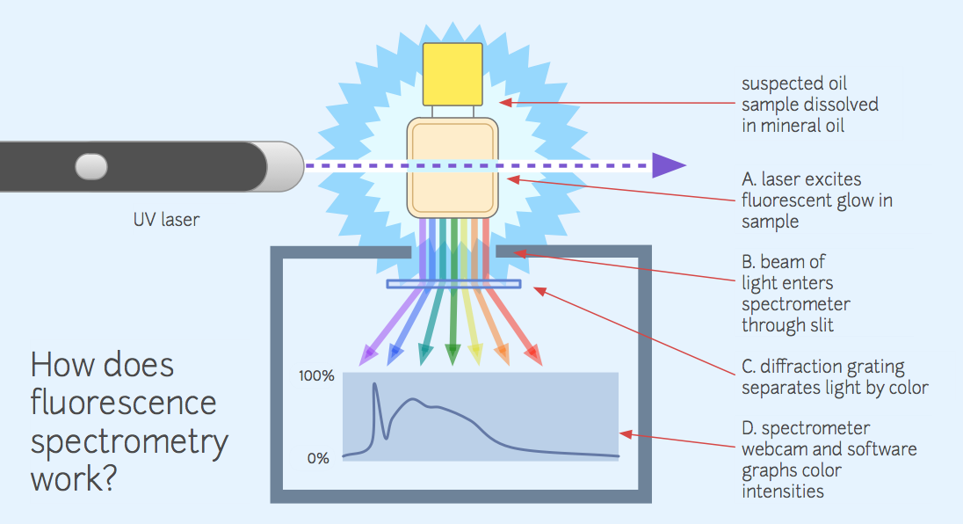

**Figure2** the mechanism of a typical type of spectrometer

There is an equation quantifying the amount of light passing through a solution: 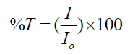

Where %T stands for the percent transmittance, and $\frac{I}{I_{0}}$ stands for the fraction of original light intensity and intensity of light reaching the spectrometer.

There’s also an equation expressing the relationship between A (absorbance) and %T:

C:\Users\thinkpad\AppData\Roaming\Tencent\Users\1165008570\QQ\WinTemp\RichOle\4J5M_P$$VK~NPVGHTNEIHE9.png

Since %T can be determined more accurately, we use the above equation to calculate A, which has a linear relationship with the concentration of the solution:

A=Ɛbc

The absorbance of the solution should be measured at the wavelength λopt (where light is absorbed most strongly). Ɛ is the molar absorpitivity, b is the solution path length and c is the molar concentration of the absorbing molecules.

When Ɛ is unknown, we need to construct a calibration curve to determine c.

**B. Preparing a Buffer**

# We can draw a line representing the linear relationship between A and c. Then the slope of the line represents the Ɛb. By measuring the A of a solution with known concentration, we can first determine the slope of a certain species. Then we can use this value to determine the concentration of a solution with known A.

# Figure3 Fe(II) sample absorbance

**C. Overview**

# In the experiment we will work in a group to first prepare 6 solutions with known concentration and then measure the absorbance of them (λmax=400nm) to construct a calibration curve. Eventually we will use this curve to relate the absorbance and the concentration of the sample phosphate solution with unknown concentration.

# Ⅳ EXPERIMENTAL PROCEDURES

**Part A Preparation of Standard Solutions**

|  |  |
| --- | --- |
| Chemicals used | Materials used |
| Phosphate stock solution (1.00×10-3 M)  2M HNO3  Ammonium vanadomolybdate (AV) solution  Two water samples (A & B) of unknown phosphate concentration | Spectrophotometer  50- mL Volumetric flask  1, 2, 5- mL Pipets and pipet bulb  Cuvettes (1 per group of students)  500mL Beakers |

1. Students will work in groups as assigned to construct a single calibration curve consisting of 6 data points having phosphate concentrations in the range 2.00×10-5 M to 1.00×10-4 M. Each student will be responsible for making at least one of the solutions and measuring the absorbance of at least one data point.

2. Based on your calculation from **step 1**, pipet 1.00mL of 1.00×10-3M phosphate stock solution, , into a 50-mL the volumetric flask labelled as 2#.

3. Pipet 2.00 mL 2M HNO3 solution into the same volumetric flask.

4. Pipet 1.00 mL of the ammonium vanadomolybdate (AV) stock solution into the same flask.

5. Dilute the stock solution by filling the volumetric flask until the meniscus reaches the mark (Figure 7).

6. Repeat steps 2 to 5 for each of the six standard solutions 2# - 6# but pipet the corresponding phosphate volume from the table instead of that shown by Step 2.

7. For the preparing the blank sample 1# repeat steps 3 through 5 (skip step 2 so do not add any phosphate stock).

**Part B Adjusting the Spectrophotometer**

1. Turn on the spectrometer (Figure 8) by rotating the power control clockwise. Allow the spectrophotometer to warm-up for 10 minutes before using. Press the “MODE” button to select %T (transmittance mode). The current mode appears on the display.

2. Adjust the wavelength to 400 nm. With no sample in the spectrometer (use only the black block and do not insert any cuvette), press the 0%T button so the meter reads 0%. Each member of the group should verify all readings.

3. Always use the same cuvette and rinse with a few mLs of solution whenever you are using a new solution.Discard the rinsing solution according to your instructor’s directions. Three-quarters fill the rinsed cuvette with the blank solution from the standard sample labeled 1#. Insert the cuvette into the sample holder of the spectrometer and press the 100%T button so the meter reads 100%. Use always the same slot of the sample holder for the remains of the experiment. Your instrument is now calibrated until completion of the experiment properly.

**Part C Making the Absorbance Spectrum & Finding λopt using a Standard Solution**

1. Rinse the same cuvette you used for your blank with about 1 mL of your standard solution 6#. Three-quarters fill the rinsed cuvette with the sample solution. Insert the cuvette into the spectrometer. Measure and record the percent absorbance A in the range of 400-450nm but measure the data at every 10nm increments.

**2.** Record your data on the table and the datasheet. Find λOPT corresponding to the maximum A. All data points for a given curve must be measured with the same cuvette. All phosphate solutions should be discarded according to your instructor’s directions. Diagram here shows typical absorbance with wave length using same sample solution.

|  |  |  |  |  |
| --- | --- | --- | --- | --- |
| λ(nm) | 400 | 410 | 430 | 450 |
| A |  |  |  |  |

**Part D Making the Calibration Curve Using the standard Solutions**

1. Rinse the same cuvette you used for your blank with about 1 mL of your standard solution 2#. Three-quarters fill the rinsed cuvette with the sample solution.

2. Insert the cuvette into the spectrometer. Measure and record the percent absorbance A in the range at λOPT once.

3. Repeat step 1 for the standard samples solutions 3# through 5# but only measure 1 absorbance for each sample 2# - 5#.

4. Record your absorbance data on the table shown by procedure Part A & on the datasheet.

**Part E Determination of Unknown Concentration**

1. Pipet 5.00 mL of the unknown phosphate solution, 2.00 mL of 2M HNO3 and 1.00 mL of the ammonium vanadomolybdate (AV) solution into the 7# 50-mL volumetric flask.

2. Dilute the solution by filling the volumetric flask until the liquid reaches the meniscus mark.

3. ¾ fill the rinsed cuvette with the unknown solution. This is Unknown 7# A. Use the spectrometer to measure its absorbance A. Using solution and same cuvette (empty), repeat procedure here to make Unknown 7# B and then measure its absorbance.

4. Now determine the unknown concentration by using the calibration curve (for further information, see references at the end of this experiment).

5. Before you leave, make sure everyone in your group has recorded on the datasheet, the concentration and the absorbance A for each of the various phosphate solutions.

Please make the curves by using software such as origin or excel.

**Ⅴ CALCULATION/ANALYSIS/DATA PROCESSING**

**Part A Preparations of Standard Solutions**

For sample1-6, we dilute 0.001M phosphate stock solution.

For sample7A-B, we dilute two unknown concentration of phosphate solution.

|  |  |  |  |  |  |  |  |  |
| --- | --- | --- | --- | --- | --- | --- | --- | --- |
| Sample | 1 | 2 | 3 | 4 | 5 | 6 | 7A | 7B |
| V(mL) | 0.00 | 1.00 | 2.00 | 3.00 | 4.00 | 5.00 | 5.00 | 5.00 |
| Conc.(M) | 0 | 2.00 $×{10}^{-5}$ | 4.00 $×{10}^{-5}$ | 6.00 $×{10}^{-5}$ | 8.00 $×{10}^{-5}$ | 1.00 $×{10}^{-4}$ | unknown | unknown |

**Table 1** Corresponding concentration of sample solutions

**Part B Adjusting the Spectrophotometer**

**Part C Making the Absorbance Spectrum & Finding λopt using a Standard Solution**

|  |  |  |  |  |  |
| --- | --- | --- | --- | --- | --- |
| λ(nm) | 400 | 410 | 420 | 430 | 450 |
| Absorbance | 0.280 | 0.224 | 0.177 | 0.141 | 0.093 |

**Table 2** Absorbance under different λ

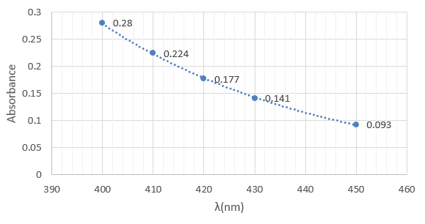

**Figure 4** Calibration curve

In our measured range, absorbance decreases as λ increases. As 400nm shows the largest absorbance, λopt=400nm.

**Part D Making the Calibration Curve Using the standard Solutions**

|  |  |  |  |  |  |  |  |  |
| --- | --- | --- | --- | --- | --- | --- | --- | --- |
| Sample | 1 | 2 | 3 | 4 | 5 | 6 | 7A | 7B |
| Conc.(M) | 0 | 2.00×10-5 | 4.00×10-5 | 6.00×10-5 | 8.00×10-5 | 1.00×10-4 | unknown | unknown |
| Absorbance | 0 | 0.056 | 0.131 | 0.184 | 0.238 | 0.280 | 0.054 | 0.083 |

**Table3** Absorbance of different samples

We use the calculator to determine the linear relationship between concentration and absorbance. A=kC+b. k=2855.7,b=0.0054. r(multiple correlation coefficient)=0.99656, which means the deviation is relatively small.

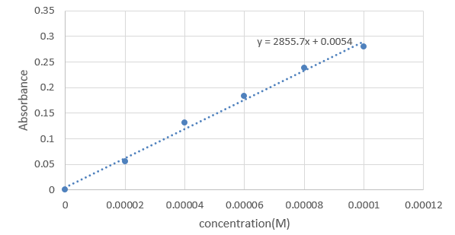

**Figure5** The best-fit line

**Part E Determination of Unknown Concentration**

We’ve found the linear relationship between concentration and absorbance: A=2855.7C+0.0054.

In Part D, we measured the absorbance of sample 7A&B, which are 0.054&0.083. We plug in the absorbance of 7A&B and get the concentration of the diluted unknown sample.

${ C}_{A}=\frac{A-0.0054}{2855.7}=\frac{0.054-0.0054}{2855.7}M=1.70×{10}^{-5}$ M

$$C_{B}=\frac{A-0.0054}{2855.7}=\frac{0.083-0.0054}{2855.7}M=2.72×{10}^{-5}M$$

Since the actual solution we use for measurement was diluted 10 times, the original concentration of sample 7A&B are:

$$C_{A0}=1.70×{10}^{-5}M×10=1.70×{10}^{-4}M$$

$$C_{B0}=2.72×{10}^{-5}M×10=2.72×{10}^{-4}M$$

**Ⅵ DISCUSSION**

In Part A, there might exist errors when preparing sample solutions. It’s difficult to use the pipet to control the volume of the 0.001M phosphate stock solution. Also, the environment temperature then was 22℃, which is different from the standard temperature(25℃) marked on the pipet. The tiny inaccuracy may result in deviation in the slope of line in PartD.

In Part C, we only measure the absorbance under the range of 400 to 450 nm with an interval of 10 nm. Therefore, we have no idea about the absorbance of λ＜400nm or λ＞450nm. The λopt=400nm we used may not be the most appropriate one. Thus, to make the data more distinguish, we should find a more suitable λopt within a larger range.

In Part E, theoretically the line should pass through the origin. However, from the equation we can see the line has a positive intercept on x-axis, which means the actual concentration of our sample solutions should be higher than recorded. Therefore, when diluting the stock solution, we might have not added enough di-water to reach the mark on the flask, causing the concentration to be higher.

**Ⅶ CONCLUSIONS ＆ RECOMMENDATIONS**

In this experiment, we’ve practiced preparing solutions again and learned how to use the spectrophotometer to measure the absorbance. We’ve also learned to use the fitting line to estimate the concentration of certain solutions.

We strongly recommend the experimenters to read the manual and listen to the instructor’s lecture carefully to ensure that they know how to operate the spectrophotometer. This will save much time and improve the efficiency.

Also, students must abandon data with a large deviation. These data may be inaccurate and will cause larger error to the process of fitting the line.

**Ⅷ REFERENCES**

-1. Peter Atkins, *Chemical Principles The Quest for Insight Seventh Edition*, Macmillan education, 2016.

-2. VC211 Laboratory Manual, UM-SJTU JI &SJTU Chemistry Department, 2018-2019.